 

**Mora Line Transmission Project**

**Three terminal 115 kV Line Elimination**

**Material Modification Assessment 1**

**Prepared By:**

**Utility System Efficiencies, Inc. (USE)**

**November 18, 2020**

**Version 1.1**

Prepared by

|  |  |
| --- | --- |
| Ben Stephenson, P.E. | Utility System Efficiencies, Inc. |

**Foreword**

Ameren, the owner of the Mora Line Transmission Project, has initiated a Material Modification Assessment to evaluate the impact of changing the three terminal 115 kV line segment of the project into two distinct 115 kV lines in order to provide operating and maintenance flexibility. The change will not physically impact the line connections at Springer or Arriba substations. This assessment focuses on the reliability impact of such change.

This Material Modification Assessment report is prepared for Ameren by Utility System Efficiencies, Inc. (USE). Any correspondence concerning this document, including technical questions, should be referred to:

**Chris Koty**

Transmission Planning Engineer

Ameren

ckoty@ameren.com

Phone: (501) 278-0256

and

**Ben Stephenson**

Principal Power Systems Engineer

Utility System Efficiencies, Inc

BenStephenson@useconsulting.com

Phone: (916) 749-8550

**Mora Line Transmission Project Material Modification Assessment 1**

**Table of Contents**

1 Executive Summary 3

2 Study Description and Assumptions 5

3 Results and Findings 5

3.1 Power Flow Analysis Results 5

3.2 Transient Stability Analysis 6

**LIST OF APPENDICES**

Appendix A – Power Flow Plots

Appendix B – Transient Stability Plots

**LIST OF TABLES AND FIGURES**

Table 1. Power Flow Results (New Outages Only) 5

Figure 1. Mora Substation Design Change (Substation is part of the MLTP) 4

# Executive Summary

Lucky Corridor LLC, finalized the Don Carlos Wind Farm System Impact Study (SIS) on March 27, 2019 under provisions of the pro forma Open Access Transmission Tariff (OATT) Section 32 to be filed by Lucky Corridor. The study was coordinated with PNM and Tri-State as affected systems.[1]

The Don Carlos Wind Farm (DCWF) project has requested to interconnect 181.44 MW gross to the MLTP using General Electric (GE) 2.5-127 turbines. Ameren has initiated a Material Modification Assessment to evaluate the impact of changing the three terminal 115 kV line segment of the MLTP project into two distinct 115 kV lines by adding a second 115 kV circuit breaker to provide operating and maintenance flexibility. The change will not physically impact the line connection to Tri-State at Springer or to PNM at Arriba. This assessment focuses on the reliability impact of such change.

The basecases used in the SIS are re-used in this study with the updated power flow models. The original SIS cases are used as the baseline to compare the performance of the proposed change.

**Figure 1** on the following page illustrates the proposed new MLTP connection at the Mora substation. An “open ring” arrangement at the Mora 115 kV will inherently protect against the transient stability concerns that occur when the Mora-Springer 115 kV line trips following a three-phase line fault with the DCWF online above 100 MW. The open ring ensures that a fault to the Mora-Springer 115 kV line open-ends the Mora-Arriba 115 kV line and the Mora 230/115 kV transformer, tripping the DCWF and inherently eliminating the transient stability concern without the need for a Remedial Action Scheme (RAS) to mitigate.

**Overview**

The technical analysis conducted as part of this MMA study includes power flow and transient stability analysis. Power factor and short circuit analysis is not impacted by this slight topology change.

This MLTP design change is permissible (not a material change) if the DCWF RAS is adjusted to align with the topology change as noted on the following page.

Figure 1. Mora Substation Design Change (Substation is part of the MLTP)

**Mora**

Don Carlos Wind Farm

Springer

Arriba

230 kV

115 kV

**Mora**

Don Carlos Wind Farm

Springer

Arriba

230 kV

115 kV

**SIS Design**

**New Design**

**Results**

This study has the following notable results:

* Trip section 1 of the DCWF RAS will need to include a second line status input as shown below in bold italics. This additional input resolves all new overloads.

1. Trip DCWF offline for an outage of any of the following:
   * Arriba-Arriba Tap 115 kV Line Segment (PNM Line that open-ends the MLTP)
   * ***Mora-Arriba 115 kV Line Segment (MLTP Line segment)***
2. Trip DCWF back to 100 MW then trip offline if the facility is still overloaded after 1 minute:
   * PNM's Arriba Tap-Valencia 115 kV Line exceeds 497 Amps

* If at any time the Mora-Springer 115 kV line is open-ended or de-energized for maintenance or any other purpose placing the MLTP and DCWF on a radial connection all to the way to Arriba, then the DCWF is stability-limited to 75 MW. This limit ensures a stable response to the next contingency.
* A side evaluation identifies that if the Mora 115 kV were a full “ring” arrangement rather than the “open ring” bus shown in Figure 1, the Don Carlos Wind Farm would be stability limited to 100 MW bound by a three phase fault on the Mora-Springer 115 kV line.

# Study Description and Assumptions

This study evaluates the impact of the MLTP change using the Heavy Summer, Heavy Winter, and Light Summer post-project cases used in the SIS. No changes were made to the DCWF power flow or dynamic model.

# Results and Findings

## Power Flow Analysis Results

The additional 115 kV circuit breaker introduces new or changes existing contingencies that was not previously studied. The most notable new contingency is a fault to the Mora-Arriba 115 kV Line which will open this line section without also tripping the connection to Springer. The thermal loading results of these new contingencies are noted in Table 1 below.

Table 1. Power Flow Results (New Outages Only)

|  |  |  | Season | | HS | HW | | LSP |
| --- | --- | --- | --- | --- | --- | --- | --- | --- |
|  |  |  | Gladstone PST | | 180 | 115 | 190 | 190 |
|  |  |  | DCWF | | 180 | 180 | 175 | 155 |
|  | Outage | Overloaded Element | Area | Rating |  |  |  |  |
|  | *NERC P0 Events* |  |  |  |  |  |  |  |
| 0 | No Outage Taken | ARRIBA_T - VALENCIA 115kV | 10 | 497 A | 94.9 | 76.5 | 98.7 | 99.8 |
|  | *NERC P1 Events* |  |  |  |  |  |  |  |
| 990 | Mora-Arriba 115kV Line | SPRINGER - RAINVL_T 115kV (to Storrie Lake) | 10 | 462 A | 84.6 | 88.8 | **109.0** | 52.7 |
| *86.9* | *88.8* | ***111.1*** | *52.6* |
| 54 | Arriba-Gallinas-Arriba Tap 115kV Line | SPRINGER - RAINVL_T 115kV (to Storrie Lake) | 10 | 462 A | 86.8 | 81.6 | **101.7** | 85.7 |
|  |  |  | *89.1* | *84.2* | ***103.9*** | *87.1* |
|  | *NERC P2 Events* |  |  |  |  |  |  |  |
| 104 | P2-3 Arriba 115kV CB (Arriba Tap-Arriba,Mora-Arriba) | SPRINGER - RAINVL_T 115kV (to Storrie Lake) | 10 | 462 A | 86.9 | 81.7 | **101.8** | 85.8 |
| *89.2* | *84.3* | ***106.1*** | *87.2* |
|  |  |  |  | **Case** | **3** | **6** | **8** | **11** |

The original Design of the DCWF RAS is summarized below. Trip section 1 of the DCWF RAS will need to include a second line status input as shown below in bold italics. This additional input re-aligns the DCWF RAS with the MLTP design change and resolves the overloads noted in Table 1 above.

1. Trip DCWF offline for an outage of any of the following:
   * Arriba-Arriba Tap 115 kV Line Segment (PNM Line that open-ends the MLTP)
   * ***Mora-Arriba 115 kV Line Segment (MLTP Line segment)***
2. Trip DCWF back to 100 MW then trip offline if the facility is still overloaded after 1 minute:
   * PNM's Arriba Tap-Valencia 115 kV Line exceeds 497 Amps

## Transient Stability Analysis

If at any time the Mora-Springer 115 kV line is open-ended or de-energized for maintenance or any other purpose placing the MLTP and DCWF on a radial connection all to the way to Arriba, then the DCWF is stability-limited to 75 MW. This limit ensures a stable response to the next contingency.

A side evaluation identifies that if the Mora 115 kV were a full “ring” arrangement rather than the “open ring” bus shown in Figure 1, the Don Carlos Wind Farm would be stability limited to 100 MW bound by a three phase fault on the Mora-Springer 115 kV line.

**Appendix A**

**Power Flow Plots**

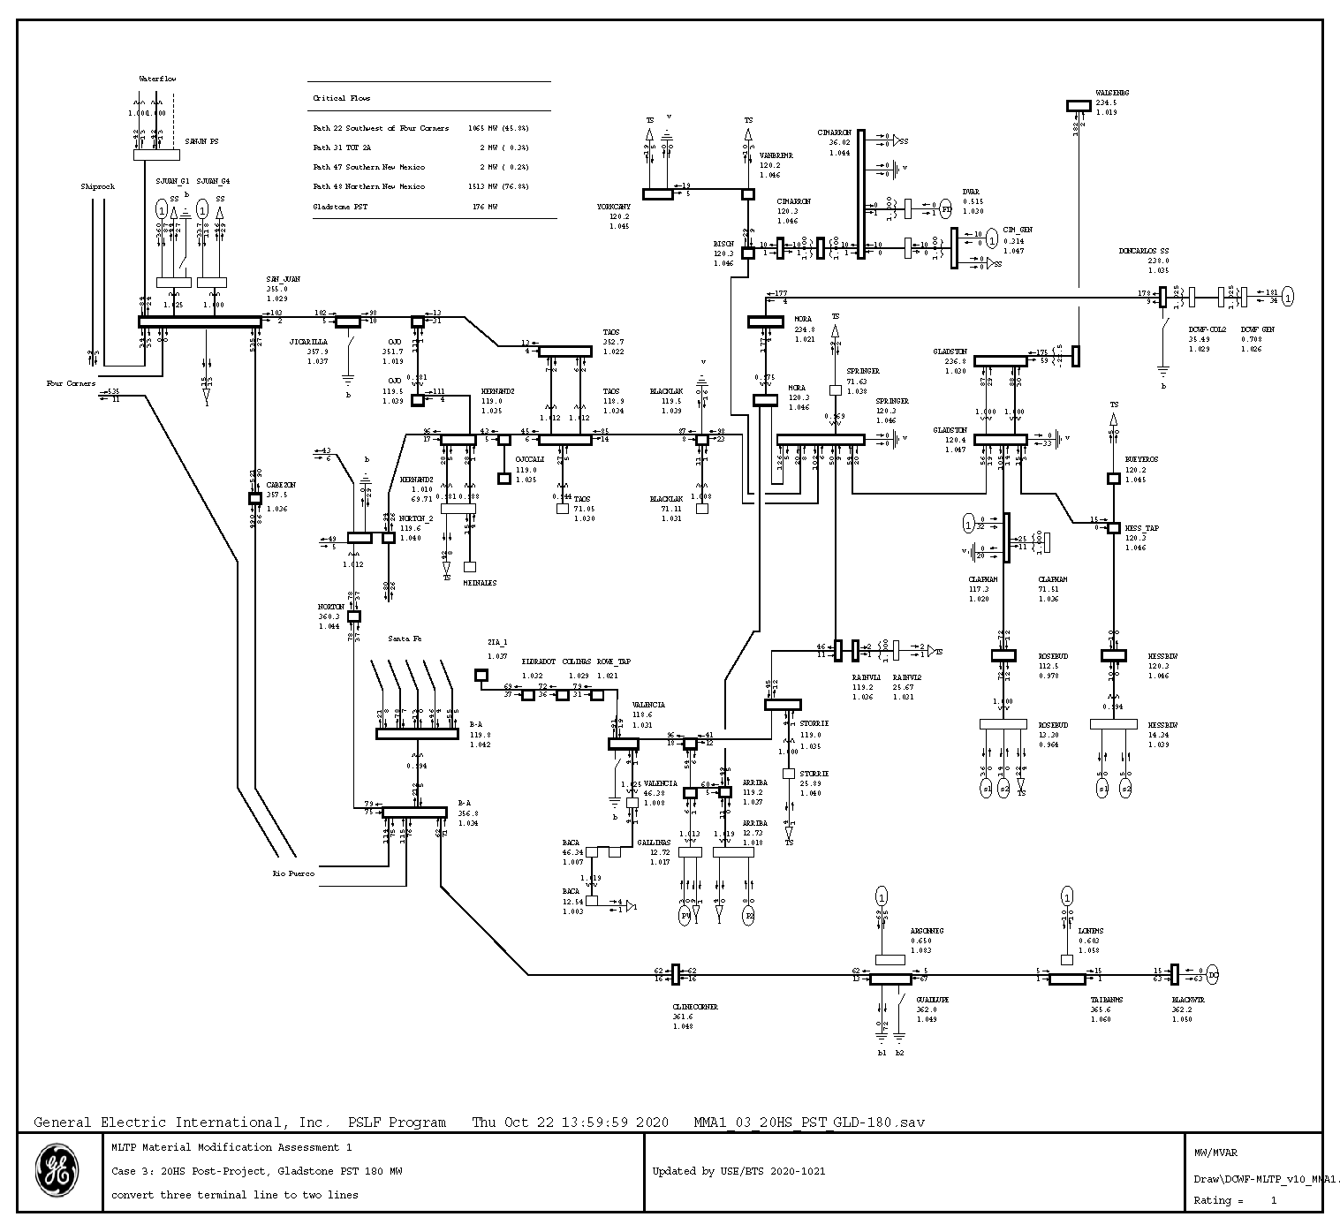

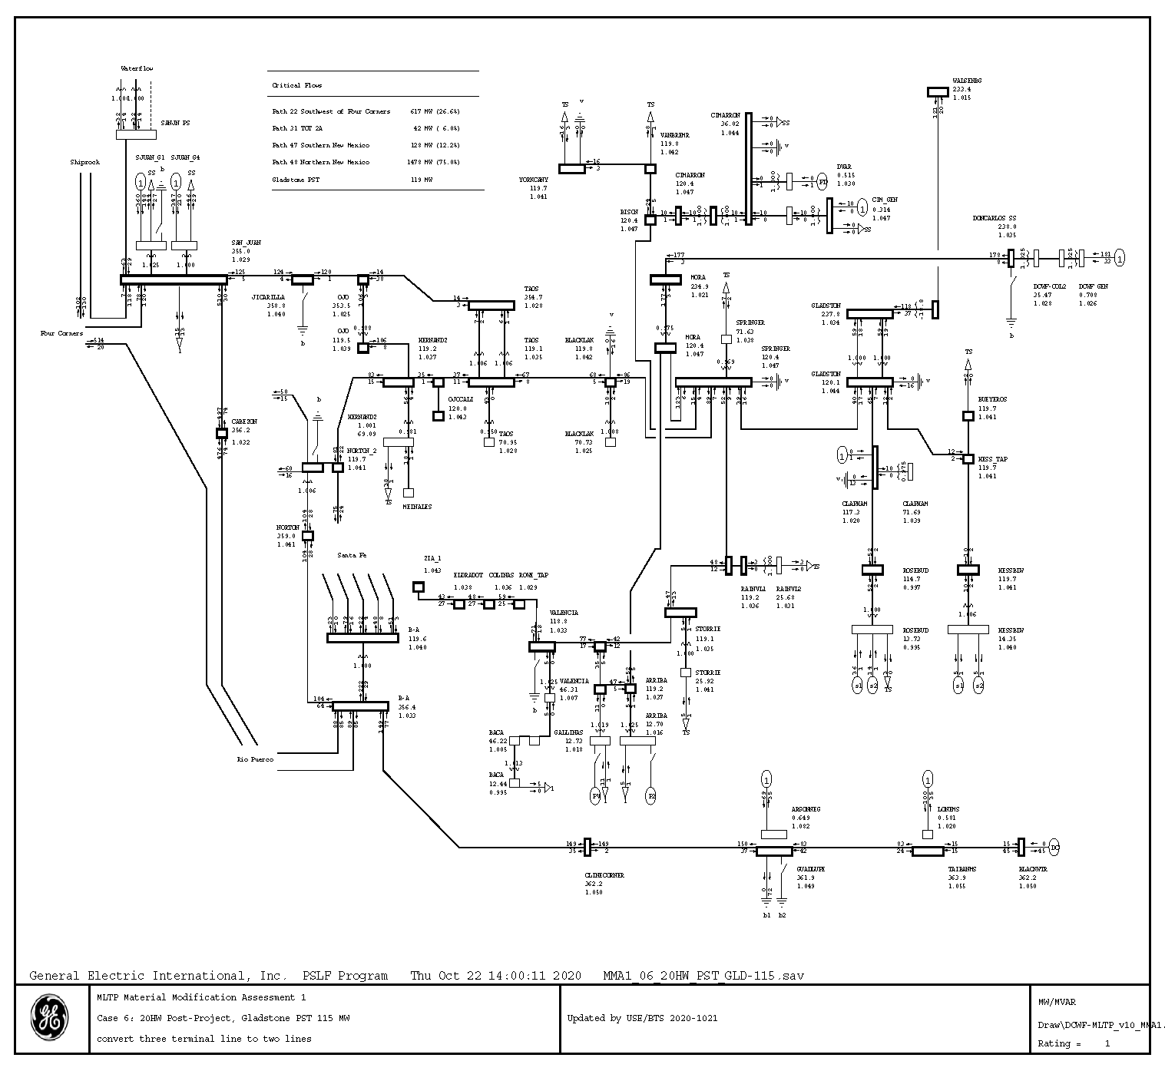

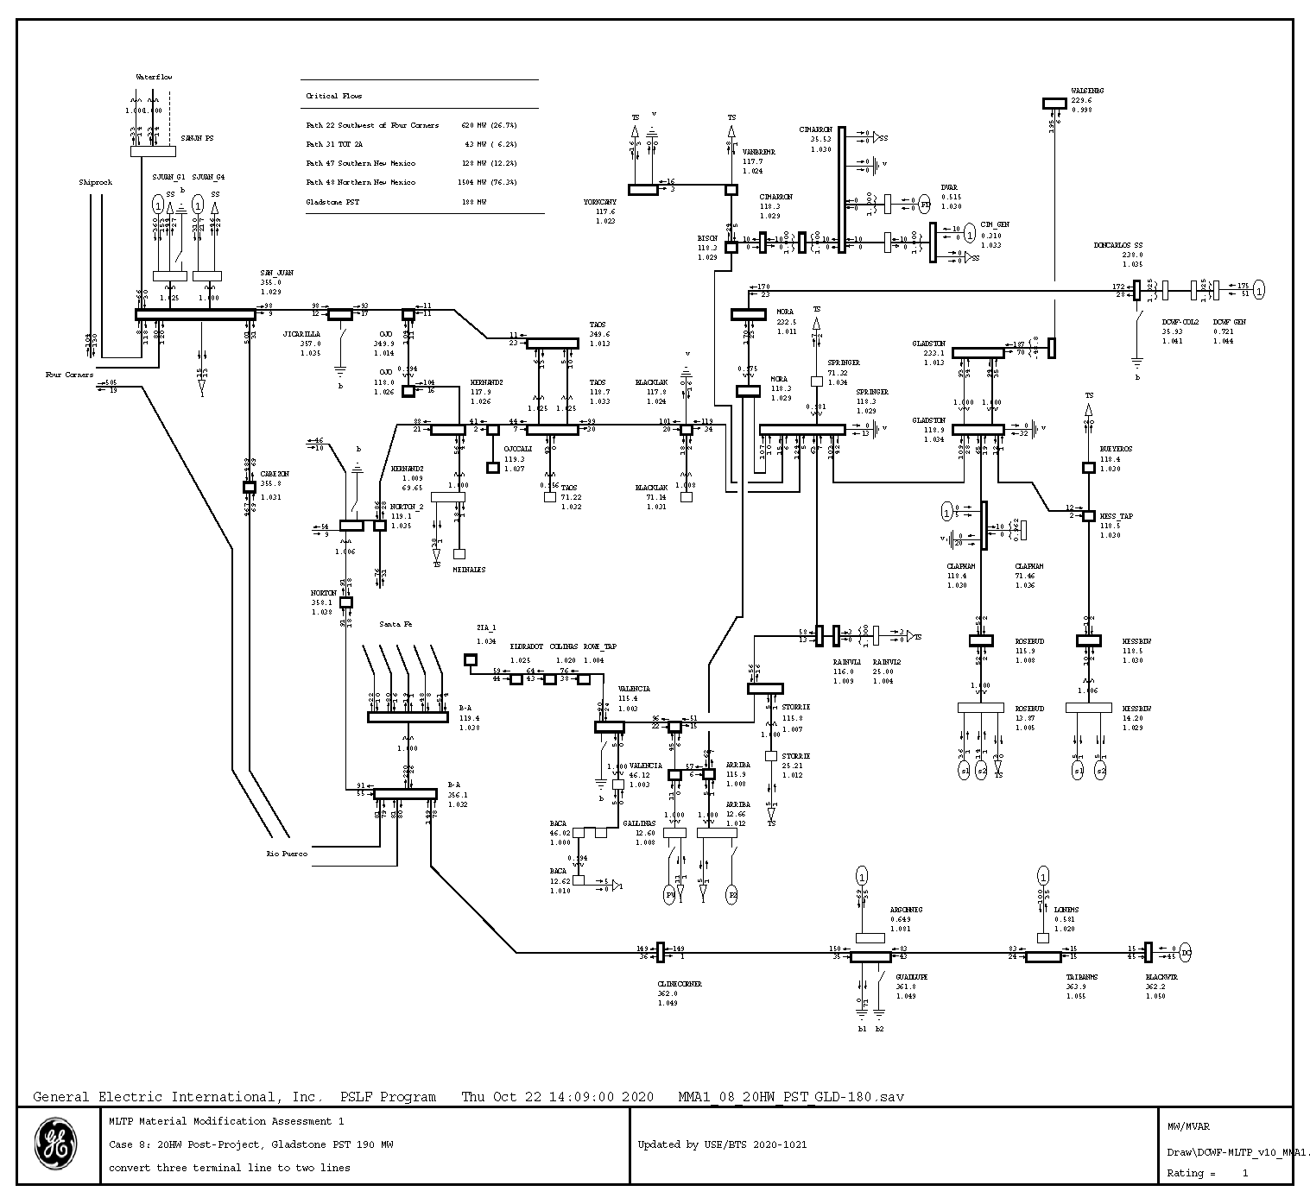

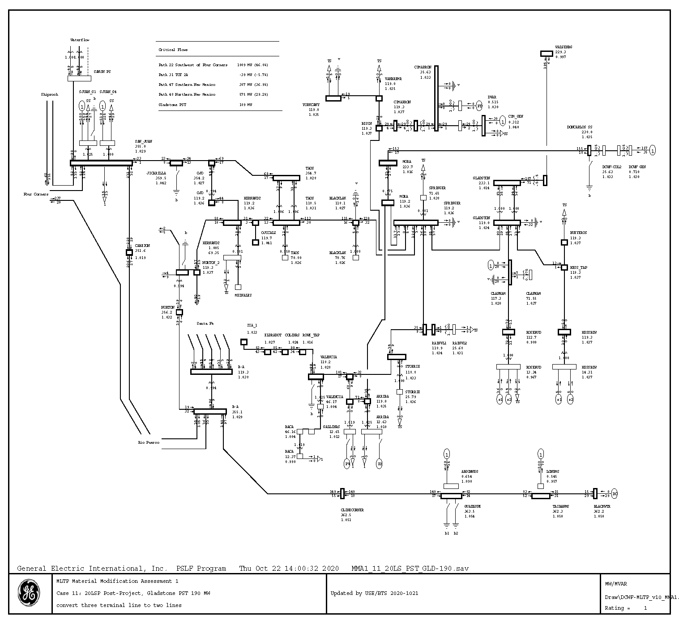

**Appendix B**

**Transient Stability Plots**

*Available upon request due to large number of plots*

1. Don Carlos Wind Farm System Impact Study Report posted on the Lucky Corridor OASIS at: <https://luckycorridor.com/oasis/>